Hotel Door Lock Management Systems
User Manual
(Smart Hotel 5.7)

Installation

Structure and Requirement
Configuration  Hardware | Minimum requirements | Suggested configuration
CUP | Intel Pentium 1GHz | Intel 1.7GHz以上
EMS Memory | 128M | 512M以上
Hard disk | 10G /1G | 40G /2G
Display card | 256 colors | True color 32bits
Ports | 1serial port, 1 USB | 1serial port, 1 USB
OS | Windows98 | Windows2000/XP

Preparation before installation

Card issuing mode

If the hotel owns more than 200 guest rooms, we recommend the building to use the Multi-point card issuing, it can increase the service of efficiency, and it matches along with more than two computers and SQL Server.

If the hotel just own less than 200 guest rooms, we recommend the building to use the Single computer card issuing, it really save the costs of the system, and it matches along with one computer and Access 2003.

Program
The building program requires a perfect plan before install the software, such as the numbers of the floors, the rooms, types of the position, office departments, level of the right and divided the time section.

Equipments
The Mifare system needs 2 MUR-100 readers, 600 pieces of Mifare 1 S50 cards, 10 Mifare 1 S70 cards, and two computers.

System installation

Software installation
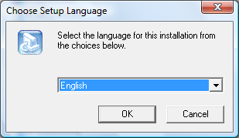
Double click the software named BT lock 5.7.30, a window will ask you to select the display language at first, there are two languages to select, one is the simple Chinese, the other one is the English.

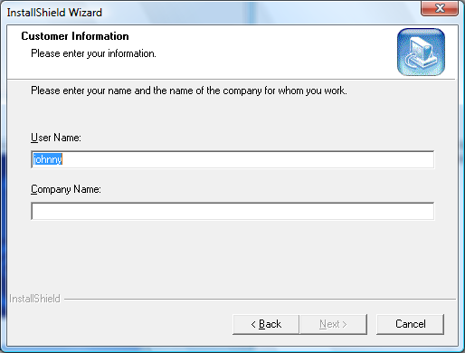
This window asks you to enter your information, when filled in your name and your company name, press the Next button to the next step.

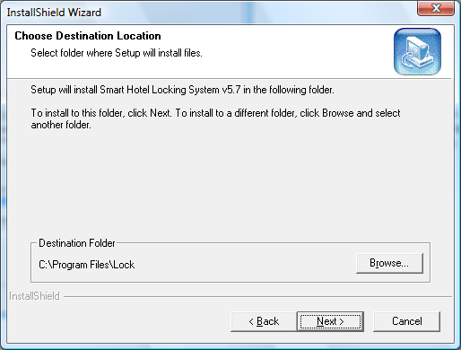
This window asks you select a folder where the software will install in. The default path is C:\Program Files\Lock.

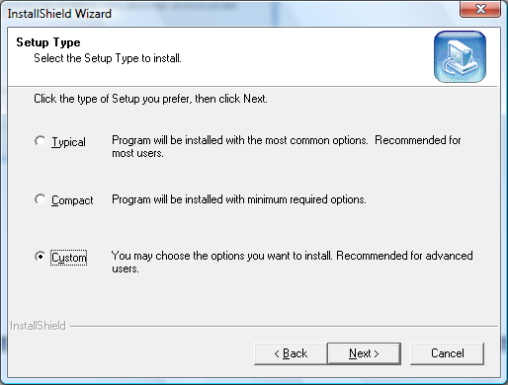
There are three setup types to select, click the type of setup you prefer and then click the Next button. Follow the indication to finish the installation.

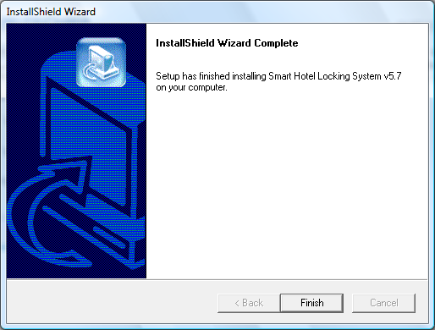
When this window turns up, the system software has been installed in the computer.

Card reader installation
The method of setup the MUR-100 card reader: Make sure the connection is right; the following procedures will show you how to finish the card reader installation.
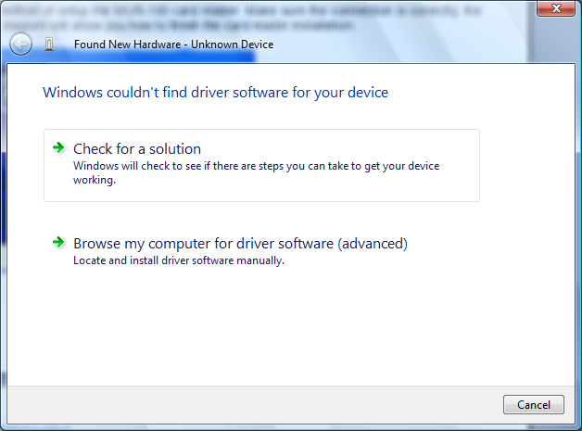
Connect the card reader to the computer and then a window will pop up, choose the Browse my computer for driver software item to go to the next step.

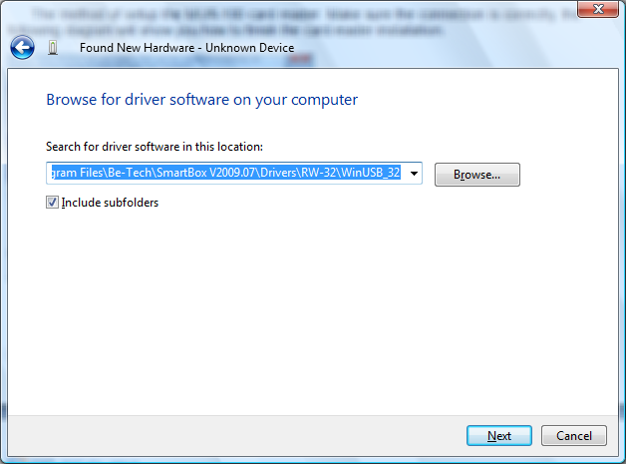
This window asks you to search for the driver software, press the Browse button to select the path. The software is installed in the C:\Program Files\Lock\ BTLock5.7\Drivers\RW-33 in default

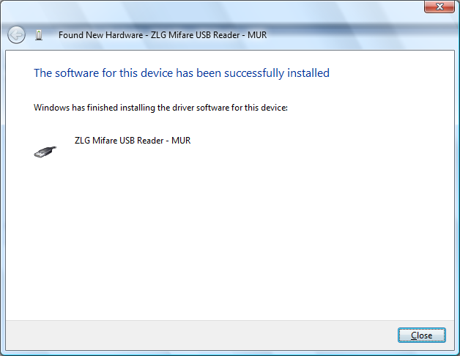
Now the card reader driver has been installed in the computer, press the Close button to close the setup window.

Notice
There are two kinds of driver for the card reader, one is for the Windows98, and the other one is for the Windows2000/XP. Please make sure your selection is right.

Handset installation
First, connect the handset with the PC, press * key to turn on the handset, press OK key and input the logon password, the default logon password is “123456”，then press OK key again, select Communicate with PC from the function menu, and start to install the handset driver.
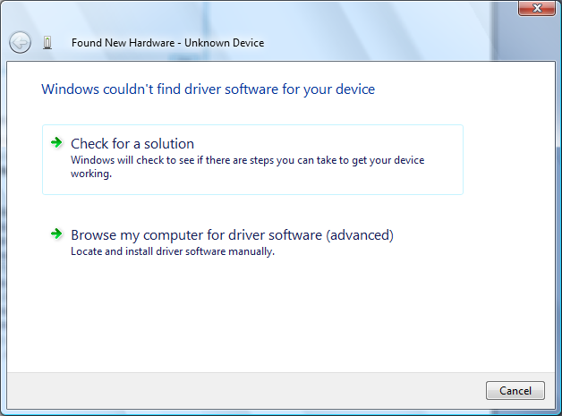
While the Waiting for communication... signal is displayed on the handset, a window pops up on the PC screen, select the Browse my computer for driver software item to enter the next step.

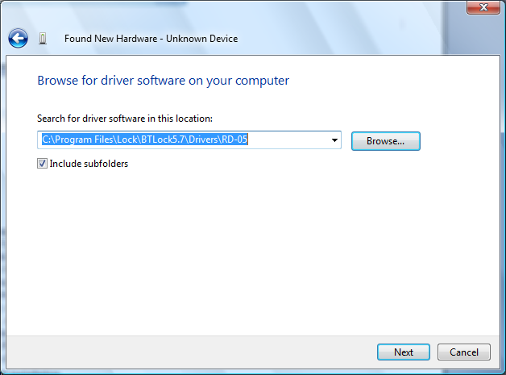
Press the Browse button to select the path, the driver of the handset is in the RD-05 folder and then clicks the Next button to process the installation.

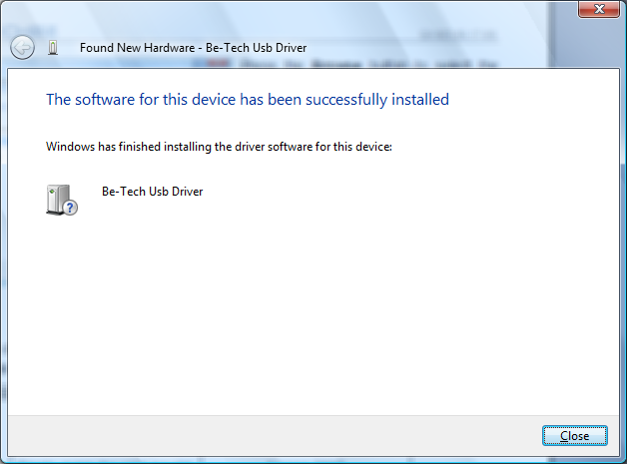
Now the handset driver has been installed in the computer. Press the Close button to exit the installation.

SQL2000 installation

This system supplies two card issuing modes to the operator. One is the single computer issuing mode, and the other is the multi-point card issuing mode. The multi-point card issuing mode can issue two or three cards at the same time, it can improve the efficiency of card issuing, but it needs two or more computers. The single computer issuing mode is used for the small hotel, it just need one computer to issue opening card,
Single computer mode
Access 2003
Multi-point mode
SQL Server

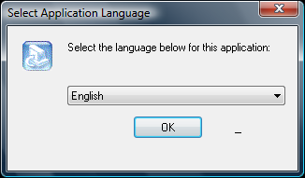
Run and text
Double click the Smart Hotel 5.7 icon on the desk, if this is the first time you run the system, it requires you to select the display language, in this system, there are two languages to select, one is Simple Chinese, and the other one is English.

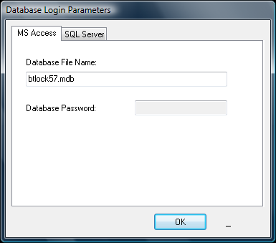
MS Access is for single computer card issuing mode. SQL Server is for multi-point card issuing mode. Select the one you prefer and then press OK button to go to the next step.

System management
When the system finished, you must setup the system at first, the following contents will tell you how to manage the MF5.7 system.

Login page
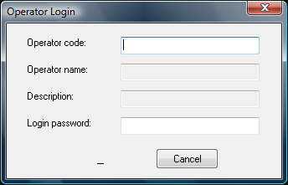
You must fill in the operator code and the password to log in the software. If this is the first time that you run the system, the operator code and the login password are blank in default, and the operator owns all the operation rights to the software system.

System setting

Basic setting
It required setting the reader and the options when you log in the system.

Reader setting：

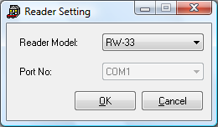
Click the “Setting” item, select the “reader setting”, the MUR-100 card reader matches along with the model “RW-33”.

Option setting：
The purpose of setting this item is to ensure normal operation of the card reader (It only needs to set once).
Definitions:

Day start time
For guests who check in after four o'clock in the morning, their stay time will be not be counted as one whole day if they leave the hotel on the same day, but their stay time will not be counted as one whole day if their stay lasts to the twelve o'clock of the next day. Four o'clock is the day start time

Check out time
The default value is twelve o'clock, guests should renew their check-in procedures before twelve o'clock; otherwise, their overdue guest cards will be unable to open the doors.

Serial number
Each guest card has a serial number, the serial number of each guest card must be larger than that of the any previously issued ones, and an old guest card would refuse to open the lock if its serial number is smaller than that of a new guest card.
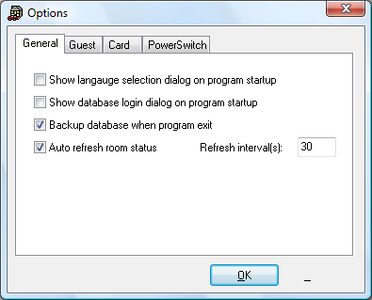
In the general item, if the system base on the Multi-computer card issuing mode, the auto refresh room status should be selected as 30s.

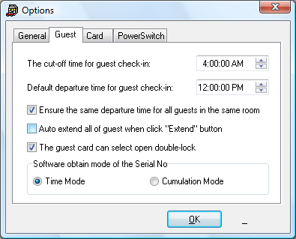
In the guest item, if a guest checks in after 4:00 in the morning and leaves on the same day, his stay in the hotel is not counted as a whole day; the check out time is 12:00 at noon to provide more time for guests to tidy up their luggage.

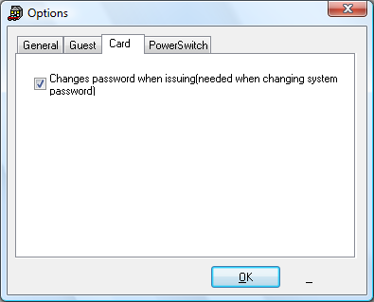
When the system password has been changed, this item must be selected. Otherwise, the issued card will be unavailable

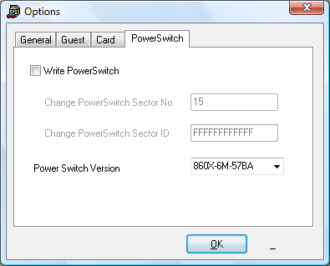
The power switch version is 860X-6M-578A in default, in general it is not necessary to change this item.

Establish room information
We can establish the room information by an elaborate plan; we can establish the information about the floors, the room numbers, the guest rooms and the common doors etc.

Floor classification:
The first floor: Lobby
The second floor: Restaurant
The third floor: Night club.
The fourth floor: Gym room 401 Ball room 402.
The fifth floor: Office
Maintenance Department501, Sales Department502, Administration Department503, Guest Room Department504, ITDepartment505, Front Desk Department506, Security Department507, General Manager Department508
The sixth floor to twentieth floor: Guest rooms
The twentieth-one to twentieth-two floor: Suite rooms

Room classification
Common doors for guests: gym room 401, ball room 402
Common doors for staffs: office rooms from 501 to 508.
300 guest rooms: 601---- 2020
5 suit rooms (larger rooms containing smaller rooms) each has 14 door locks:
2101---2101A、2101B、2101C
2102---2102A、2102B、2102C
2103---2103A、2103B
2201---2201A、2201B、2201C
2202---2202A、2202B、2202C

Create buildings

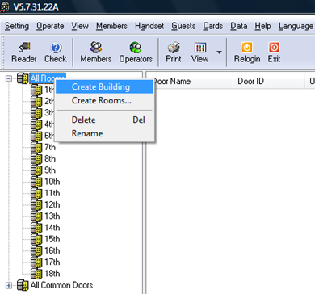
Right click the All Rooms item in the tree list box at the left side of the window and then add the floor1 to floor3, the floor 6 to floor22 into this item.

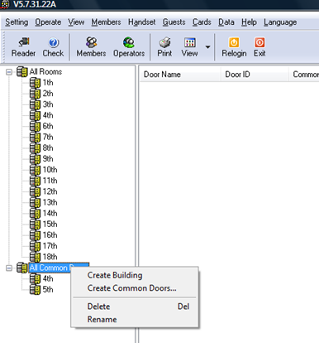
Right click the All Common doors item in the tree list box at the left side of the window and add the floor4, the floor 5 into this item.

Create rooms

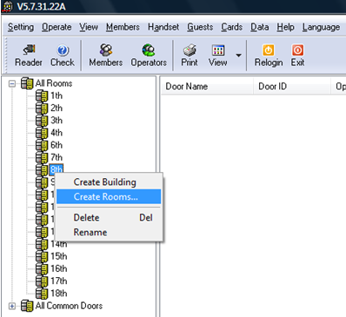
Now create the rooms of the 8th floor as a simple:
Right click the 8th floor and then choose the Create Rooms item.

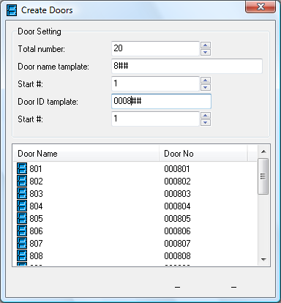
Due to every floor own 20 rooms that we should set the total number to 20. The door name set to “8##”, the door ID set to “0008##”, both of their start number is “1”. Click the Apply button to finish the operation. Follow the above steps to add all the rooms of each floor.

Create common doors

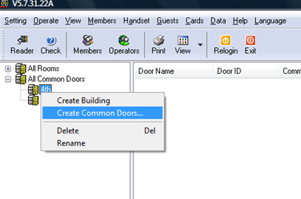
The common doors is use to setup a passage mode. It is often used for the public place like the restaurant or the ballroom etc. Click the All Common doors item, right click the 4th floor, choose the Create Common doors item.

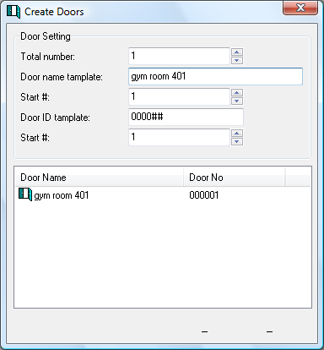
The total number write 1, the door name write gym room 401, start # write 1, the door ID write 0004##, the start # write 1, then press the Apply button to finish the operation. Follow the above procedures to create the ball room 402 into the 4th floor.

Establish system password
The system password is use to distinguish the different MF system. The users can change the system password according to his owned requirement.
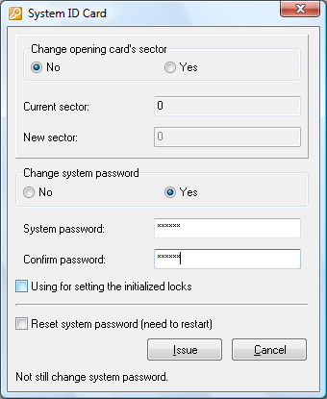
Connected the card reader with the PC, put a MF 1S50 card on the card reader, then select the Cards item on the main menu, then select the System ID card item. The Change opening card’s sector is use to change the sectors of the 1MF cards for the Smart All-in-one Card service. It is not necessary to change in common. We just need to change the password and press the Issue button.

Establish time section
Time section is use to analyze the work time. Only the corresponding work time could be accept to open the door. At this case, we divide the Sunshine hotel work time into six sections like this:
Morning shift | Middle shift | Night shift | Morning shift | Middle shift | Night shift
8:00-16:00 | 16:00-00:00 | 00:00-8:00 | 8:00-16:00 | 16:00-00:00 | 00:00-8:00
Monday to Friday | Monday to Friday | Monday to Friday | Sat Sun | Sat Sun | Sat Sun
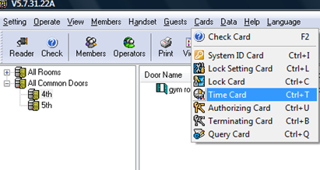
Connected with the PC, put a MF 1S70 card on the card reader, click the Cards item on the main menu and then select the Time Card item.

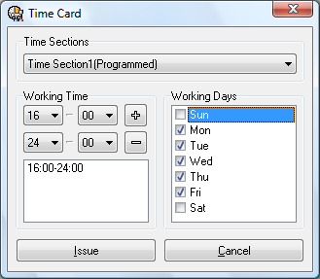
After the menu pop up, select Time Section1, the time writes 16:00-24:00, the day select the Monday to Friday, then press the Issue button to make a time card, make all the left time sections like the above procedures.

Establish operator information
The Operators module is use to achieve the function of system operator management. The main function in this module is divided the operating rights. Here, we can divide the operators into 3 categories:

Global Right
Owns the highest rights to operate the system, the members are the general manager and the hall manager.

Local Right
This group owns lots of rights except for the assign operator right and the issue card right. The members are the department manages usually.

Service
This group owns the lowest rights in the system, that is the guest manages right only, authorized to issue guest cards. The members are the front desk servers.
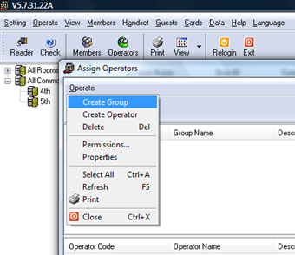
Click the Create Operators item on the main menu.
Create three groups, and rename the groups as Global right, Local Right, Service.

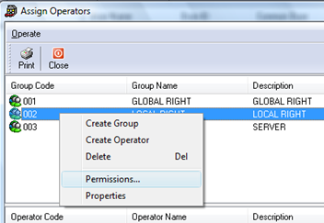
The 001 group owns the highest rights in default. So we just need to authorize the authorities for the 002 group and the 003 group.
Right click the 002 group and then choose the Permissions item in order to go to the next step.

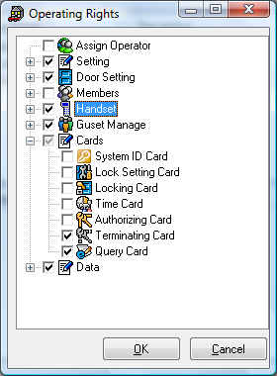
Due to the operators in the 002 group are the department managers generally, we can authorize the rights of the 002 group as the left diagram.

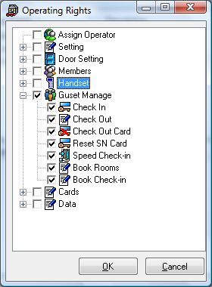
The 003 group are the services generally, they just need to manage the guest information. Authorize the rights of the 003 group as the left diagram.

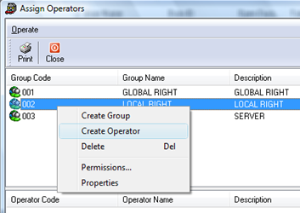
Create staffs for each authorized group. Modify the password. Right click the 002 group and then choose the Create Operator item to go to the next step.

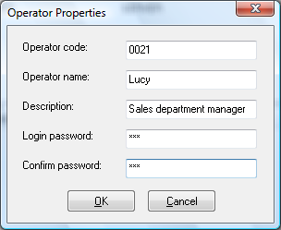
After operators are added, to enter the software, the operator code and password must be entered. Press the OK button to return to the Operators interface. Press the Close button to return to the system interface.

Establish member information
The Members module is use to achieve the function of system members management. The main function in this module is divided the position and issue the emergency card, the staff card, and the temporary card.

Create the groups and the members

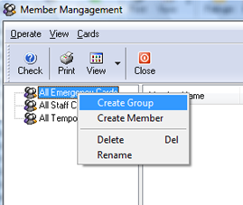
Select the Members item on the main menu, right click the All Emergency Cards item, choose the Create Group, and rename the new groups as the General Manager.

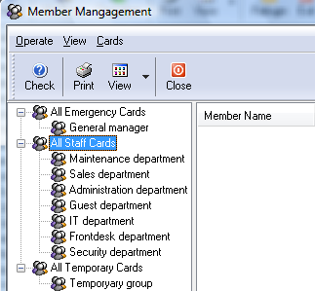
Follow the above steps to add all the groups into the system, such as the left diagram.

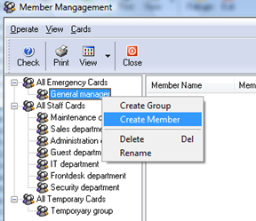
After all the groups have been created, we should create the members now. Right click the General Manager and then choose the Create Member item.

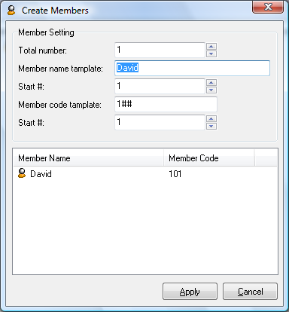
A window will turn up, now the window requires you to fill in the member information. After all the information has been registered, click the Apply button to finish the procedure and click the Cancel button to return to the system. Follow the above steps to add all the members into the system.

Notice
Every Member code template is the unique and it is a sign of member. So before the adding, please assign the code template to every member by a plan.

Issue member cards
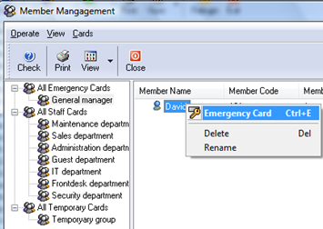
All emergency cards: In this group, the members are the general managers, who own the highest right in this hotel, and he can hold a emergency card, that own the highest right for opening.
Put a Mifare 1S50 card on the card reader and then right click one of members in the General Manager group, choose the Emergency Card item to issue an emergency card.

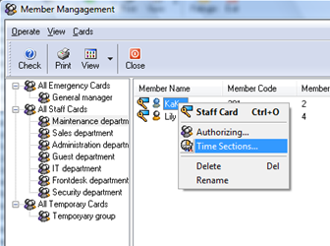
All staff cards: In this group, we divide the positions into 6 kinds as show as the left diagram. Before you issue a staff card, you must set the Time section for the staff. Here we assign the time section 1 for Kaka and then press OK button to save the time section setting.

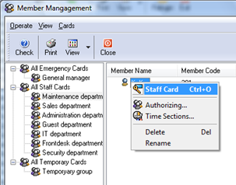
After that, we can put a Mifare 1S50 card on the card reader, then right click one of members and choose the Staff Card item, after one beep a staff card will be issued successful and now this staff card holder is KaKa only.

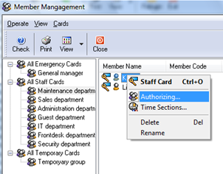
After a staff card has been issued, you can authorize the staff which room he can open. Select a staff named KaKa, right click the staff name, and choose the Authorizing item.

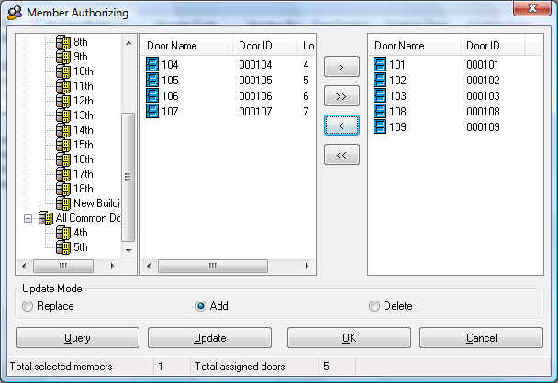
A window will turn up for authorizing. You can select rooms on the left square frame and press the > button or press the >> button to add rooms to the left square frame. After adding rooms, press the OK button to save the setting. On the left diagram we will see the No.101, No.102, No.103, No.108, No.109 room were authorized for KaKa to open.

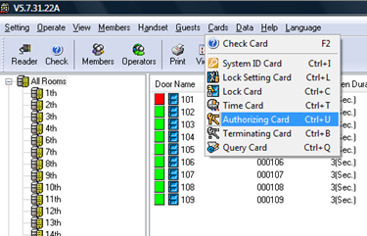
After all the staffs have been authorized, you should return the system interface. Select one room and choose the Authorizing Card item (as show as the left diagram) in order to make an authorizing card.

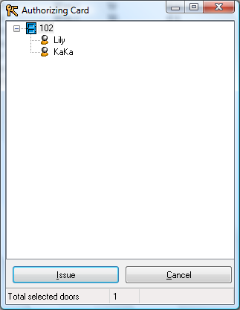
This window asks you to insure the members who were authorized to open No.102 door. Now we will see the No.102 room was authorized for Lily and KaKa to open. Put a MF 1S70 card on the card reader, and then press the Issue button, an authorizing card will be made for the No.102 room.
Take this card to contact the lock and the authorized member information will be set into the lock after one beep.

Notice
Before the authorizing operation, the time section must have been set and the staff card must have been issued. Otherwise, the staff card may be unavailable.
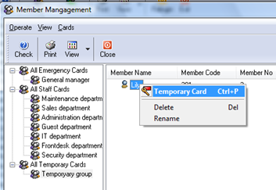
All temporary cards: In this group, the members are the guest room manager in common. They can own a temporary card. This card is usually used to open lock when the main card was lost or in an emergency.

Notice
Only the staff card selected the leading mode, the temporary card can be available.

Handset
The handset is use to set door lock information, to query door lock information, compare with the card setting mode, the handset setting mode is operated more easily, more conveniently and more quickly.
Query info
PC
Handset
Door lock
Query info
Set info
Set info
Handset mode

Set lock information
Before we record the lock information from the PC, we must make sure that the hotel system password, the authorized information, and the time section have been setup already. The hotel system password is made by the system ID card, the time section is made by the time card, and the authorized information is made by the members authorize management function.

Connect with computer

Connect the handset with the PC,

Press * key with more than 3s to start the handset, than fill in the handset password to run the handset, the default password is 123456, press OK key to log in the handset, then select Communicate with the PC in the menu of the handset, an indication message Waiting for communication is displayed on the handset screen.;

Return to the management, software and choose the Handset item on the top main menu, selected the Handset setting function. Press the Set time button in order to set the PC time into the handset. The Get time function is used to display the handset time. Press the Update SP button in order to record the new password from the system;

Then select the Write handset function. In this page, firstly select the rooms to be set from the floor tree at the left side of the window, then press >or >> to add rooms;

After step C is completed, click Next button to set the information to be written into the handset including door lock setting information, work time section, and blacklist.

After the information is set in the blacklist, click “Next” to write the selected room information into the handset;

After the room information is written into the handset, disconnect the handset from the PC.
Notice
The door lock setting information is only for unallocated rooms to be written into the handset, except Other Items which include all the selected rooms to the written into the handset.
Notice
If the number of the authorized staffs exceeds the rated value, a window will pop up for users to delete the surplus authorized staffs, the system will refuse to write the authorization information of the room into the handset if the number of the authorized staffs still exceeds the rated value.

Connect with locks

Connect the handset with the door lock;

Select the Setup sys pw ,in order to setup the system password into the door;

Select the Adjust lock’s time ,in order to setup the lock time;

Select the setup look’s info, then choose the room code which is matched along with the room number, in order to setup the lock’s information;

When setup successful is displayed on the handset that means this lock is already set lock information in. When connecting failure display on the handset, you must check the connection;

Disconnect with the lock. Repeat the above steps until all of the hotel door locks are set completely.

Query lock information

Connect the handset with the door lock;

Press * key to start the handset;

Connect the handset with the door lock;

Select Download lock’s info in the menu of the handset, press OK key to summarize door lock information;

After summary is completed, connect the handset with the computer;

Select Communicate with the PC in the menu of the handset, press OK key, an indication message waiting for communications displayed on the handset screen;

Click Read data button, after displaying the suitable room list in the handset, select the rooms to be summarized, and then save the door lock information and unlocking records in the handset into the database of the software; the Read data button is mainly used to save the door lock information in the handset into the database of the software, analyze the queried door lock information through the data Query button, and display the analyzed information in each window;

Right click the room item in the tree list box at the left side of the window, then click Query, the analyzed information in the database corresponding to the rooms to be queried will be displayed in 6 summary information fields, including basic lock information, time sections, blacklist records, temporary card information, staff card information, and access records.

Guest room management
The guest room management is divided into 4 parts: the booking management, the check-in management, the check-out management and the lock information management. In this module, we can issue the guest card, the check-out card, the reset SN card. The process of this module is show as the flow chart:
Guests
Check-in

Guest card
Info
Check-out

Guest info
Status
Check-out card
Booking

Room No.
Batteries

Booking room
This module is use to achieve the booking room function. Note: This operation is only available for the clean and vacant room, or the non clean and vacant room.

Book room
Before booking a room, we must select the room No. and register the guest’s information, including the guest name, the telephone number, the ID card, etc. The Modify button is use to change the number of card. Click the Book button to finish the operation. After a room is booked, the room status will be changed into booked.
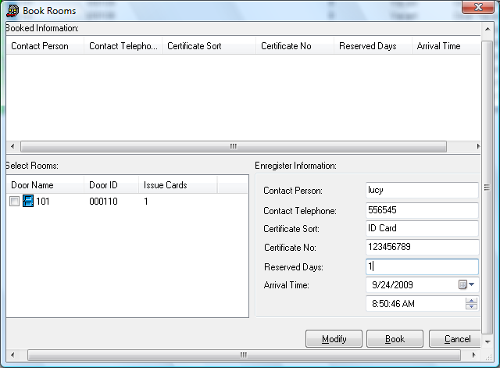

Book check-in
We can also issue a guest card for a booked room. Click the booked room once and select the Guests item on the main menu, then choose the Book Check-in function. Select the contact person, then press the Issue button, after that, a guest card for a booked room will be issued. The Countermand button is use to cancel the reservation.
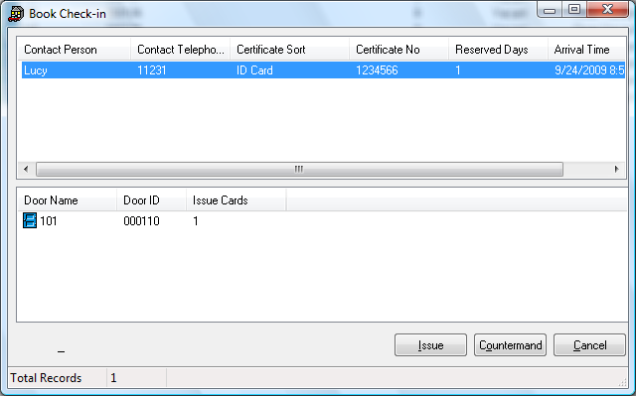
Notice
The system will book all the suite of the room in default.

Check-in management
This module is use to manage the process of check-in management. It divides into 4 functions: Guest information registered, check-out time confirmation, issue guest card, and the speed check-in.
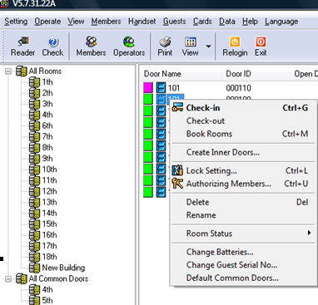
Register information: Right click the room No, then choose the Check-in item, when a menu pop up, we can register the guest information. Click the check-in button at the left corner.

Notice
This operation is only available for the clean and vacant room, the non clean and vacant room, and the occupied room.
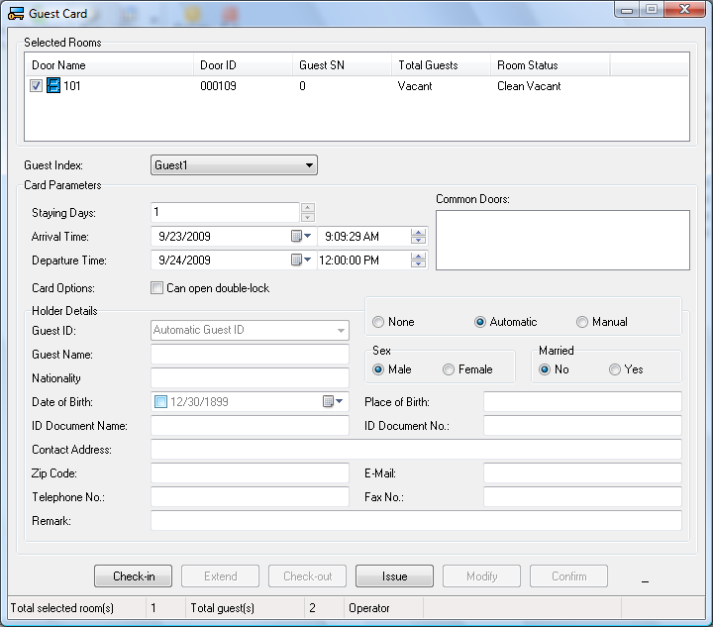
Issue guest card: When the information are registered, you should put a MF 1S50 card on the card reader, then click the Issue button to make a new guest card for the guest. The check-out time is at 12:00 next day in default.

Notice
There are three managerial mode about the information of the card holder, they are the None, the Automatic, the Manual .The None mode means the guest is not necessary to register his information; The Automatic mode means it is necessary to register the information, but the guest ID is managed by the system. In the Manual mode, the guest ID can be managed by the operator.

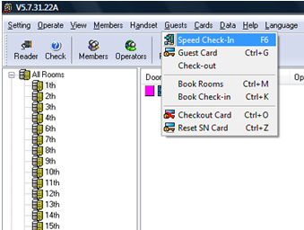
The MF system supply a particular service named Speed check-in for the special guests, like the hotel members, VIP guests etc.

.

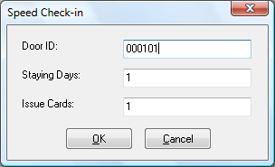
This window requires you to write down the door ID, the staying days, and the issue card numbers. Put a MF 1S50 card on the card reader and press the OK button. Then a guest card will be made.

Check-out management
There are two methods for check-out: the Automatic method, the manual method.

Automatic method
When the check-out time was passed, the guest card would be unavailable, and the status of the room would be changed into none clean and vacant.

Manual method
For an example, the check-out time is 12:00, but a guest wants to check-out the 301 room at 9:30, what should we do?
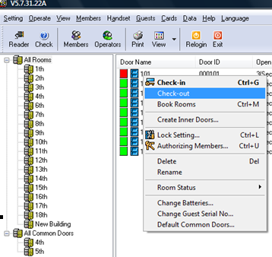
First, the front desk server should take back the guest card, and then check-out the 301 room in the system: right click the 301 room, choose the Check-out item. Then a check-out card is needed. Select the Guests item on the main menu and then choose the Check-out card item.

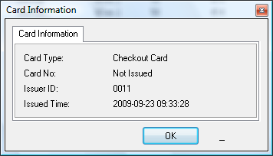

Put on a MF 1S50 card on the card reader, then press the Issue button, a check-out card will be issued. Put this card at the front of the 301 door clock, if the door lock beeps once, and the yellow lamp flashes, that means the check-out operation was finished.

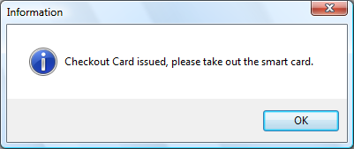
When this window turns up, it means that a checkout card has been issued successful.

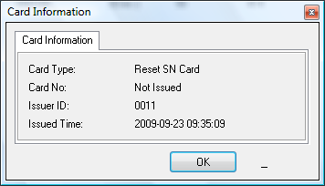
Reset SN card
The reset SN card is used to reset the guest SN.

Lock information management
This module is used to manage the lock’s information, like what time we shall change the batteries, manage the guest SN, and setup the common door in default.
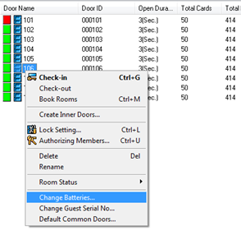
Change the batteries
The batteries should be changed after 10 months.
Guest SN
The guest SN is used to ensure every guest card owns its exclusive SN. Select the time mode as the software obtain mode of the Serial No, that will be ensure every guest card owns its exclusive SN.
Common doors
We can select the 401 room and the 402 room as the common doors.

Introduction of each card
We can also set the door lock information by the Mifare 1S50 and the Mifare 1S70 cards. The system ID card, the setting card, and the lock card are made by the Mifare 1S50 card. The time card, authorizing card, the terminating card and the query card are made by the Mifare 1S70 card. Compare to the handset setting mode, the costs of the card setting mode is inexpensive, but it is not suitable for mass production. The flow of the card setting mode is show like this:

PC

Door locks

MF Card

Card reader

MF system

System ID card
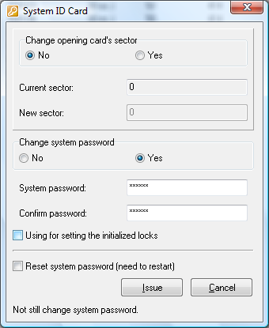
The original password is set by the Philips. Every Mifare card owns its exclusive SN. Before we supply the Mifare cards for the customers, the password will be changed by the Be-tech company, the Be-tech lock only distinguish the Be-tech’s password. After the hotel’s password was written into the Mifare card, the Be-tech’s smart lock would distinguish the Be-tech’s password at first, the Mifare card will write the password into the smart lock.

Notice
The system ID card is made of MF S50 card.

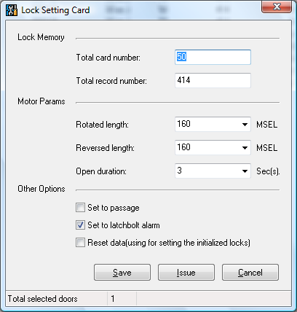
Setting card
Setting card is used to set the total staff numbers and query the opening records. If the records are full of the EMS memory, the latest record will be saved, and the earliest record will be deleted.

Notice
The setting card is made of MF S50 card.

Lock card
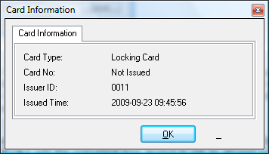
The local card is used to lock a door temporarily. For an example, if a guest wants to go out for some days, at the same time a lock card is needed. When the lock card contact to the door, the green lamp flashed and the lock beeps once, it means the lock was locked. When then red lamp flashed and the lock beeps twice, it means the lock was unlock.

Notice
The lock card is made of MF S50 card.

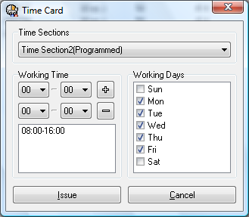
Time card
Time card is used to setup the work time section, and the time section will be saved in the door locks. For example, a staff card was assigned the Time Section 2 as his work time, the time section is Monday to Friday, so he just can open the appointed lock on Monday to Friday.

Notice
The time card is made of MF S70 card.

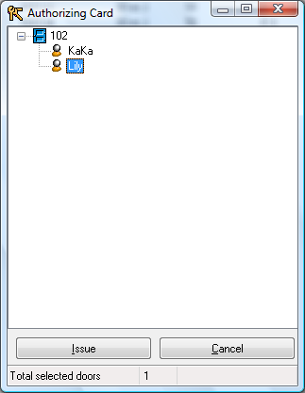
Authorizing card
Before the authorizing operation, the time section must have been set and the staff card must have been issued. Otherwise, the staff card will be unavailable.

Notice
The time card is made of MF S70 card.

Terminating card
The terminating card is used to affect the lost card out of action. Selected this function, when a window pop up, we will see all the issued records on the left block diagram, select the card which was lost (We can also select the lost card by the inquiry conditions), then click the > button to add the lost card into the right block diagram. At last, we just need to press the Issue button to make a terminating card. Scan the terminating card, it beeps once and the green lamp flashed, that means the operation was successful.
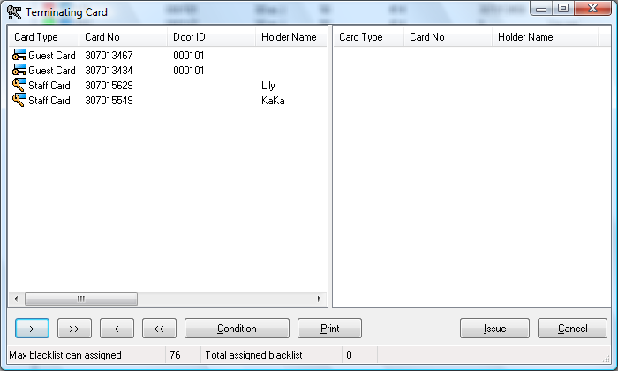

Query Card
There three summary cards, class A summary card, class B summary card and class C summary card. Scan them one by one, the green lamp glows, wait for several seconds (the default value is 5 seconds) until it peeps once, summary is completed. After all the three summary cards are summarized, all lock information is summarized. The put the three cards on the MF card reader one by one, click the Query lock information button, followed the directions to finish this operation.
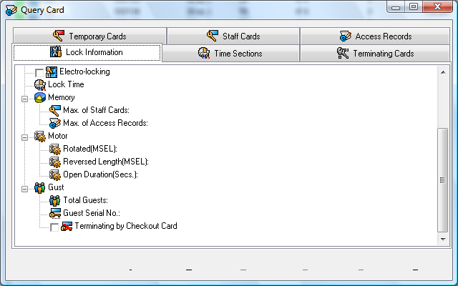

Database Management
Background from the main database management system support, including the completion of various forms of data maintenance, database backup and restoration work.
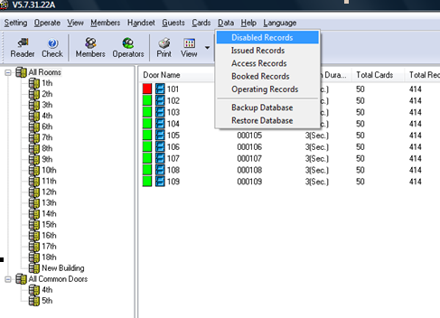

Record inquiry
The records are including the disabled records, the issued records, the access records, the booked records, and the operating records. We read all the records by the condition inquiry every time.

Database backup
We can backup the system setting as mdb type.

Database Restore
If the system setting information were lost by accident, you can restore the info by the *.mdb file.

